Unit 9 Assignment Instructions – CIS164 
For the Unit 9 Assignment we will be working with regular expressions and how they can be used to search for and return information.
Please make sure to fully read each question to ensure that you answer each question per the requirement. Also, please ensure that all responses are in complete sentences, free of spelling and grammatical errors.
*Unit 9 Grading Rubric (45 Points):
Assignment Requirements | Maximum Points | Points Earned
1. Regular Expressions - 1 | 0-5 Points
2. Regular Expressions - 2 | 0-20 Points
3. Regular Expressions - 3 | 0-20 Points
Points Deducted for Spelling or Grammatical Errors
Total (Sum of All Points)
*Directions for Submitting Your Assignment:
Complete your assignment ensuring all questions are answered based on the assignment requirements. When the Unit 9 assignment is complete, please save your file in the following format, “Lastname-Unit#.doc” (Example: Smith-Unit9.doc). You may also utilize a Word Processing software such as LibreOffice for assignment completion. In this case the assignment may be saved in .odt format, (Example: Smith-Unit9.odt). Then when ready submit your file to the “CIS 164 – Unit 9 Submit Assignment” activity for grading.

1. Regular Expressions – 1
- Provide an example of where you think the use of regular expressions would be helpful when writing a script.

While writing scripts themselves, regex can be helpful in finding potential code errors or typos just like the PyCharm IDE does. IDEs also use regex to find and replace code snippets similar to word editors.

2. Regular Expressions – 2
- Start the PyCharm IDE. Select “File->New Project” on the next screen then under “Location” change the word “untitled” to “Unit9”. Then click the “Create” button.

- Highlight your “Unit9” project in the Pycharm IDE then right click. When you right click a menu will appear, from this menu select New->Python File. Then a dialog box will appear, in the “Name” field of the dialog box type “Unit9Regex1.py”.

- Next within your Unit9Regex1.py file, type the following; **Note make sure you type this in, do not copy!**:

emailstring = ‘Cochise College has multiple email addresses to include admissions@cochise.edu and fa@cochise.edu which are important to know!’

- Next, modify your Unit9Regex1.py file to search for the string ‘emailstring’ above and then print out all email addresses contained within the string.

- For your script, you will need to provide a screenshot showing your completed script, and you will also need to submit it in a text file, along with this document.
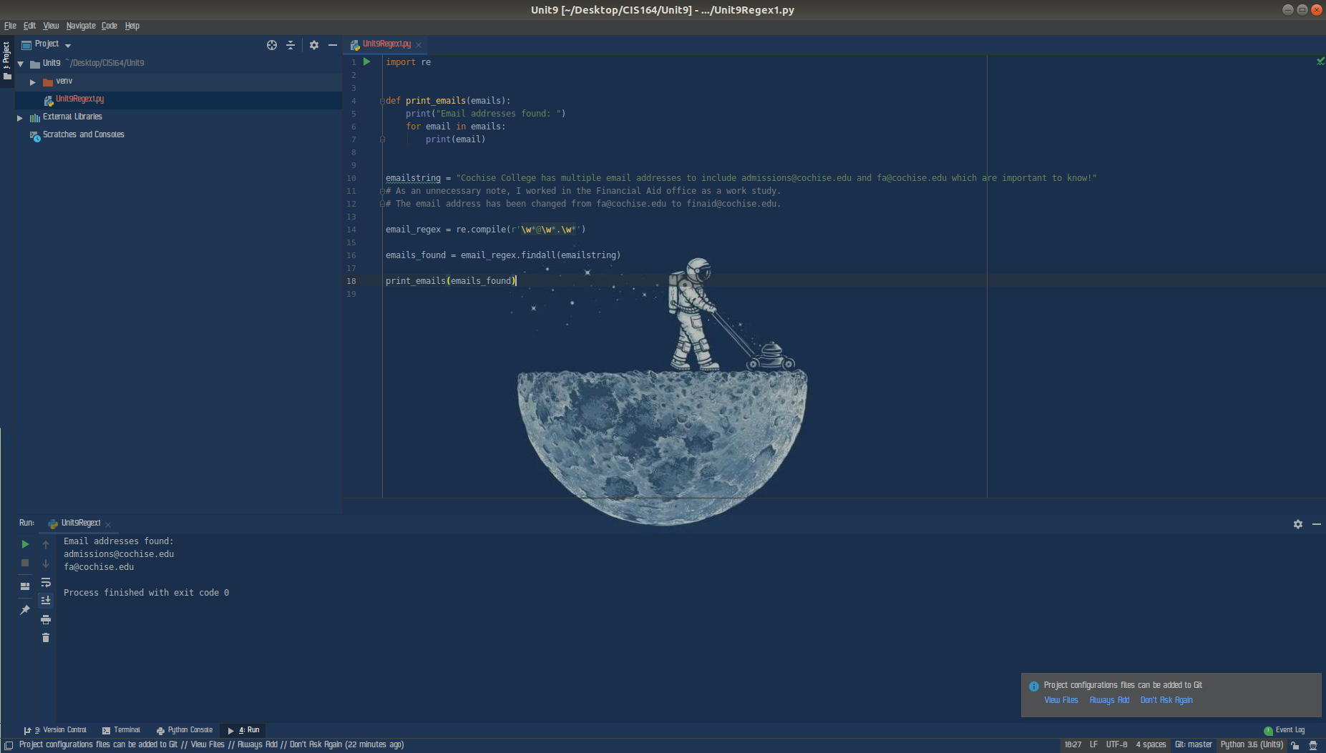

3. Regular Expressions - 3
- Highlight your “Unit9” project in the Pycharm IDE then right click. When you right click a menu will appear, from this menu select New->Python File. Then a dialog box will appear, in the “Name” field of the dialog box type “Unit9Regex2.py”.

- Next within your Unit9Regex2.py file, type the following; **Note make sure you type this in, do not copy!**:

websitestring = ‘Cochise College has multiple websites to include http://www.cochise.edu and http://my.cochise.edu which are important to know!’

- Next, modify your Unit9Regex2.py file to search for the string ‘websitestring’ above and then print out ONLY the first website contained within the string.

- For your script, you will need to provide a screenshot showing your completed script, and you will also need to submit it in a text file, along with this document.

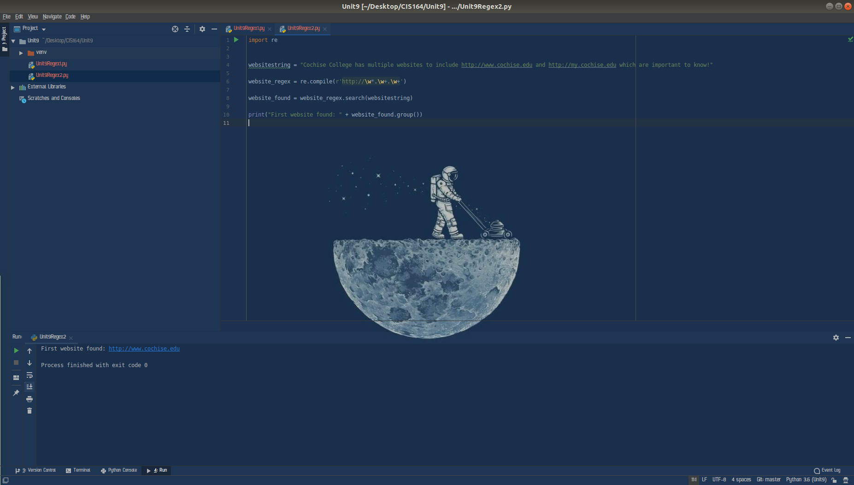

As an additional bonus (and because I misread the question initially) here is a code snippet for finding all websites in the given string:

